Chapter 17, Problem 48.

For the circuit in Fig. 17.80,

i(t) = 20 + 16 cos (10t +45°) + 12 cos (20t -60°) mA

- find v(t), and
- calculate the average power dissipated in the resistor.

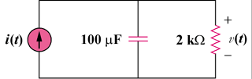

Figure 17.80
For Prob. 17.48.

